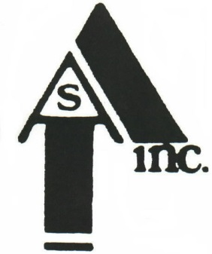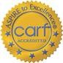
Administrative Offices:
45 Queen St.
Cumberland, MD 21502
301-777-1700 (2105)
Archway Station, Inc.

RECOVERY HOUSING PROGRAM WOMEN WITH CHILDREN (RHPWWC)

PROJECT LOCATION: 125 FAYETTE STREET CUMBERLAND, MD 21502
OLD SAINT PETER AND PAULS CONVENT BUILDING--RENOVATION

LOCATION: 125 FAYETTE STREET, CUMBERLAND, MD.

Contact: Jim Raley, Executive Director; EADS Architects Tim Hoffman (Somerset, Pa.)

Requirements: Federal Housing and Urban Development (HUD) and Community Development Block Grant (CDBG) funds—Must adhere to Davis/Bacon Wage Scale; Build America, Buy America; and Section 3 which requires economic opportunities are made available to low and very low-income persons “to the extent feasible.” Additionally, advertisements were provided in order to encourage MBE and WBE participation. The winning bidder will be required to adhere to all regulations and submit to a “conflict of interest” agreement.

BIDS WILL BE ACCEPTED UNTIL 2 PM (EST) ON MARCH 19, 2026 AND OPENED AT 2 PM AT 45 QUEEN STREET, CUMBERLAND, MD. SUBMISSIONS SHOULD BE IN SEALED ENVELOPE MARKED “125 FAYETTE STREET” AND ELECTRONIC SUBMISSIONS SHOULD BE SENT TO jim.raley@archwaystation.net. ELECTRONIC SUBMISSIONS WILL BE PRINTED AND SEALED AT TIME OF RECEIPT.

PRE-BID MEETING REGISTRATION—ARCHWAY STATION CONSTRUCTION BID—
125 FAYETTE STREET CUMBERLAND, MD.

CONTACT NAME:_______________________________________________________________________________________

COMPANY:_____________________________________________________________________________

ADDRESS;_____________________________________________________________________________

CITY/STATE/ZIP:________________________________________________________________________

PHONE NUMBER(S):___________________________________________________________________________

Email Address:_______________________________________________________________________________

DATE OF INSPECTION IF NOT AT PRE-BID MEETING:________________________________________________________

COMMENTS/QUESTIONS:

